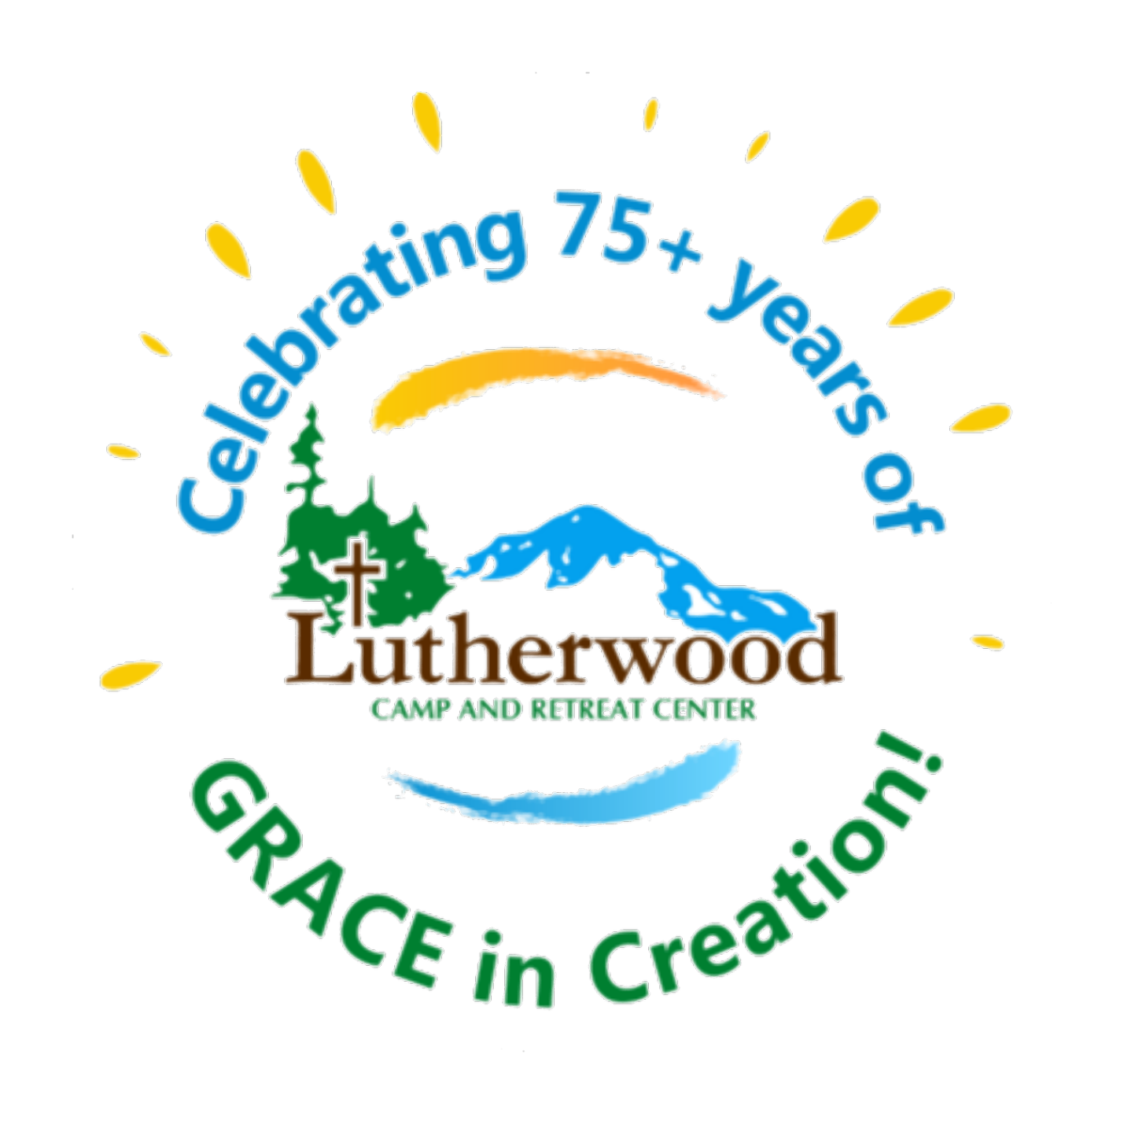
Lutherwood 2023 Annual Meeting
February 4, 2023 10:00 AM

Lutherwood Camp and Retreat Center
Annual Meeting Agenda for 2/4/2023

Welcome Judy Engh
Devotion Pastor Kristy Daniels
Land Acknowledgement Statement Tamarah Lee
Hymn Gather Us In – Marty Haugen
Approval of 2022 Minutes (vote) Kristina Daheim, Board Secretary
Executive Report Judy Engh
Program Report Nicole Klinemeier
Facility Report Mike Dilley and Keith Dickson
Finance Report/ Approval of 2023 Budget Janet Deters
Lutherwood Mission, Vision, Values (vote) Tamarah Lee, Board President
By-Laws and Nominating Committee Report Pastor Kristy Daniels, Janice Stepp
Election of Nominating Committee (vote) Mike Dilley, Board Vice President
Adjournment and Closing Lord’s Prayer

Go in Peace. Serve the Lord!

Minutes from Lutherwood Annual Meeting - 1/29 via Zoom 10:00 am
Staff Members in attendance
Rob Gillespie - Executive Director
Linaya Kolke - Program Director
Board members in attendance:
Barry Harter - Edison Lutheran Church, Edison
Mike Dilley - Oak Harbor Lutheran, Oak Harbor
Kristina Daheim - Our Savior’s Lutheran, Bellingham
Pr. Kristy Daniels - Church of Steadfast Love, Seattle
Nicole Klinemeier - Peace Lutheran, Seattle
Dave Finstead - Central Lutheran, Everett
Janet Deters- Phinney Ridge Lutheran Church, Seattle
Janice, Salem Lutheran, Mt. Vernon
Abby Coe - First Lutheran Richmond Beach, Shoreline
Absent: Tamarah Lee - First Lutheran Richmond Beach, Shoreline
Members/Congregations in attendance:
Beth Vickery - Our Savior’s Lutheran Church, Everett
Bob & Maryanne Ramborger - First Lutheran Church, Mt. Vernon
Curt Tveit, Burlington Lutheran Church, Burlington
Dave Myers - Oak Harbor Lutheran Church, Oak Harbor
Pr. Douglas Stensby - Salem Lutheran Church, Mt. Vernon
Esau Cuevas - Church of Steadfast Love, Seattle
Kari & Steve Ranten - Burlington Lutheran Church, Burlington
Larry Bean - Peace Lutheran Church, Silvana
Liza Okan - Christ Lutheran Church, Ferndale
Marcia Pratt - Salem Lutheran Church, Mt. Vernon
Mark Tanis - Holy Cross Lutheran Church, Lk. Stevens
Meg Hill - Gloria Dei Lutheran Church, Lynnwood
Patricia Schmidt - Prince of Peace Lutheran Church, Everett
Pr. Rebecca Langholz - Zion Lutheran Church, Ferndale
Steve Deters - Phinney Ridge Lutheran Church, Seattle
Tom Dickson - Prince of Peace Lutheran Church, Everett
Tom Lindsay - Gloria Dei Lutheran Church, Lynnwood
10:02 - Rob calls meeting to start
10:05 - Barry - Devotion
10:07 - Minutes from Last year’s meeting unavailable, will review at next meeting
10:07 - Rob Gilespie - Executive Report
● Recap on 2021 changes/updates
● 75+ year celebration
● Call to be a voice in their congregations about what the camp has to offer

10:19 - Linaya Kolke - Program Director
● Mini introduction of her background and how she came to Camp Lutherwood
● Recap of first 6 months (CIT fall retreat and how the 2021 summer session went)
● Provided a breakdown of upcoming 2022 program and events (recruiting,
retreats,camp prep, summer camp, etc)

10:29 - Mike Dilly - Facilities Report
● Recap on 2021 projects
○ Water damage in Spirit Lodge
● Upcoming plan to share the future needs/projects on website to help showcase
how you can help (hours, needs, etc)

10:33 - Janet Deters - Finance Report

● Recap on how 2021 finished strong - with a profit of $10,811.06 for the year
● Upcoming Budget proposal shared
○ 10:44 Motion to approve 2022 budget - Pr. Kristy Daniels
■ Mike Dilley seconded the motion
■ Approved

10:45 - Abby Coe- Proposed Mission, Vision, and Values
10:50 - Abby Coe - Proposed Bylaws change
● Talked about how congregations will be able to communicate thoughts about the
proposals over the coming year
● Member request for digital copy to share with their congregations
● Appreciation for more of a Pan-Lutheran acceptance in proposed language
change

11:00 - Board Nominations - Dave Finstad
● Abby Coe and Tamarah Lee - Current members renewing with another term
● Lize Okan & Beth Vickery - Incoming members
● Request for additional floor nominations made 3x per Robert’s Rules of Order
● Motion made by Janice Stepp
○ Seconded by Tom Dickson - Prince of Peace Lutheran Church, Everett
○ Approved
● Board Nominating Committee
The following members have been nominated or volunteer to serve on the Board
Nominating Committee for 2022:
○ Barry Harter
○ Pr. Rebecca Langholz
○ Dave Finstad
■ Motion to approve Board Nominating Committee made by Janice
Steers
■ Second by Dave Finstad
■ Approved

11:08 - Adjourn with Lord’s Prayer led by Rob Gillespie
Letter from the New Interim Executive Director, Judy Engh

Greetings Lutherwood People!
I am SO happy to be here and I am SO grateful for the welcome I’ve received! Thank you very
much! I’m writing this at the end of my first day at Lutherwood. Today I was able to walk
different areas of camp with different staff to get a sense of the physical aspects of Lutherwood.
I was also able to meet with several people in person and by Zoom which continued my journey
of getting to know the spirit of Lutherwood through the people of Lutherwood. What a wonderful group of people! God is at work at Lutherwood and you are the hands at work!
Going through an executive director vacancy/transition is hard - even if the circumstances are
all good. The year round staff and Board of Directors need to be commended for their work in
moving the camp forward and holding things together during the vacancy. As your interim
director, I promise to do my best to work with you all to keep the camp moving forward by
learning your history, meeting the people who are, have been, or will be active in the future
ministry of Lutherwood. I will be asking lots of questions and working with you all to have a
positive direction for the future ministry of Lutherwood.
I’ll be working remotely the next few weeks (from my home in Alaska) and I’m very available by
phone, email, or video. Please do not hesitate to contact me if you have anything that you want
to share. My email is executive@camplutherwood.org.
I hope to see you all at camp this summer!
In God’s Love and Grace!
Judy Engh
Interim Executive Director

Lutherwood Camp and Retreat Center Program Report for 2022
2/4/2023

Program | Total Participants | Cost per participant
Day Camp | 55 | $225
Embers | 8 | $225
Family Camp | 16
High School/CIT | 44 | $550
Music Camp | 114 | $575
Specialty Camps | 48 | $550
Traditional Camps | 100 | $475
Camp Phoenix

Camp was at 60% capacity for 2022 due to early year Covid Protocol. Those restrictions were released as we grew closer to the summer, but it still affected the total registration. We were grateful to be able to welcome back and host Camp Phoenix.
For programming for 2023, we’ve already seen an initial registration that has over 40 kid total registered for camp outside of music camp. There has been a request for a younger Adventure Camp option that includes Mountain Biking. 2023 also includes the addition of two weekends in August where Lutherwood is hosting “Grief Camp” for children who have suffered the loss of a family member. This camp will be run by Peace Health Medical Center.
Local private schools continue to reach out and use Camp Lutherwood for a place for environmental education as well as outdoor ministry activities. Rowing clubs, collegiate and community, are hosting weekend training events at Lutherwood for additional revenue this winter and spring.
2023’s Spring Elementary Retreat already has 45 Campers registered for a weekend in March. There were less than 10 children who attended in 2022.
The focus for marketing and having groups utilize the ropes course for 2023 will be part of community programing. In addition, the “camping” ministry for families on weekend has changed focus for groups who are both neighborhood friendly, as well as faith based. The plan for the last weekend in July now includes a Lutheran Extravaganza. Details to follow. We would also like to entertain the idea of a “camp host,” with an RV, hosting guests on weekends to give onsite staff a break.
We are excited to hire a new Program Director, and to see what that program director can do at Lutherwood!
Facility report 2022- Keith Dickson and Mike Dilley
Repaved gravel Road around camp.
Fixed roof and porch at Upper OAP that was damaged by a tree.
Installed new hoop at basketball court.
Cleared leaning trees away from vertical playpen.
Fixed a reoccurring clogging toilet in Apartment.
Got a new toilet installed to replace the out of service toilet in the main bathhouse.
Upgraded shop from 20 Amp to 30 Amp to prevent circuit trips.
Fixed broken water pipe and replaced damaged drywall section in dining hall.
Cleared out all the overgrown plants at the amphitheater.
Cleaned off all debris from roofs and gutters.
Cleared a downed tree that was on the boy’s bathhouse roof.
Cleared the water tower road of brush so that it can be driven on safely again.
Replaced out of service heaters in Lakeview, Outback, and the girls side bathhouse.
Replaced out of service bridge that goes to the point (thanks Pastor Kristy and the Church of Steadfast Love!)
Cleared brush from all remote sites.
Replaced normal outlets with GFCI outlets in upper contact tank. (outlets were tripping and turning
the heat off; this caused our water pipes to burst.)
Cleared the junk that has been stored behind the shop for many years.
Both motorboats were taken into a shop and tuned up for next season.
Renovated sink in apartment due to water damage.
Replaced tires on red truck, little white van, and little blue truck.
General maintenance like oil changes and changing mower blades are done to all motor vehicles.
Mowing. Raking. Blackberries. Repeat.
Reorganized bunks in Lakeview, Spirit and Bungalow to better accommodate families.
Assessed bids for major plumbing projects around the kitchens and bathhouses. Gathered bids for paved trails to the waterfront, campfire and dock to help improve accessibility for all.
Replaced furnaces and propane lines in lodges. Replaced tank and propane line to the stove/oven in the kitchen.
Treasurer’s Report 2022- Janet Deters

It seems the last two years I had to report that the pandemic affected our planning and operations. This year inflation is the culprit. Overall income for the 2022 year was less than projected by the small amount -$1,866. Facility rentals and food services were overbudget by $18,432. Summer and year-round programs were less than budget by $10,766. Donations-All Other shows lower than expected income. This is due to the auction being included in this budget line but reflected on the statement with no estimated budgeted income.
This year the auction was smaller in scale but still successful raising a little over $16,000.
Inflation is seen in the categories of food, program, canteen, utilities and the vehicle and boat line items. There were also unexpected boat and vehicle repairs that needed immediate attention. The result to Net Ordinary Income is a loss of $111,667, more than $13,827 than budgeted. The Other Income line item is from unexpected one-time gifts totaling $51,562. The final result is a net loss for the year of $60,105.
The endowment fund beginning of year balance was $1,332,787 and the end of year total is $1,272,966. Now for better news for 2023. We are projecting an operating income of more than $26,000. We have increased summer program, facility rental and food service fees to be closer to current prices.
Registration for summer camp is already open and have received a number of registrants. We do expect donations to also increase. Operating expenses will also increase to reflect current costs. Staffing with additions and summer program staff salaries reflect the largest budget item increase to bring them to more current industry standards. With all the changes reflected the 2023 budgeted operating income is projected to be $735, 445 and expenses $708,985 for an estimated income of $26,480.
Treasurer’s report submitted by Janet Deters on February 4, 2023. Please see Attachment 1 to review the 2023 Proposed Budget.

President Tamarah Lee: Mission, Vision and Values

Mission: Exploring Grace in Creation.

Vision: People of any age, ability, identity, and economic opportunity are welcomed, nurtured, and valued as a diverse body and a blessed part of God's creation.

Values:
Growth- Growth in oneself and community is fundamental, limitless, and irrevocable. Growth occurs when we are challenged while we create and respect safe environments. This allows for everyone to explore faith, nature and relationship with God at a pace and depth that they choose.
Renewal- Renewal occurs when time and space are set aside for reflection, practice, and rest. We are renewed through salvation and thus restored.
Adventure- Adventure happens when one approaches unknown risks and activities with faith and joy. Adventuring occurs when people are free from judgment and have access to discover the complexity of nature and God in a safe way.
Community- Community and families have diverse values, needs and gifts. Communities are built through fellowship, connection, hospitality, and appreciation for the Body of Christ.
Education- Education that allows people to transform, develop, and understand relationships and the world around them in a new way. Education occurs through opportunity, exploration of the world, continued learning and lived experience.
Strategic Plan Brainstorming Update: Focus for 2023 and Beyond
Please bring to your congregation, and ask for them to contribute!
Accessibility
All Buildings ADA compliant (buildings and facilities accessible)- do we have enough building/facilities for camp capacity/needs?
Grounds ADA compliant (mobility device accessible)
Web presence navigable and easy/intuitive to use for all users (accessible and Trauma Informed)- Registration easy and clear to navigate, messaging on site easy and clear for new users (eliminate 'insider' language)
Clear directions and signage across camp site (Ground signage navigable for all users, maps available and visible, buildings clearly marked)
Internet connectivity (wifi accessible across camp, will increase ease of use for other groups/individuals)
Transportation (partner with local churches to provide transportation during summer camp, or for retreats)- establish plan and structure for access and communicate that clearly on website, etc
Scholarships, funding (communicated clearly, access based on clear set of standards and communicated clearly, should some folks get full camp scholarship including camping gear?)
Clear Staff Communication plan and approach in place (for board to support )
Inclusivity
Partner with local preschool for outdoor preschool opportunities during the slow months
Land Acknowledgement and indigenous awareness (communicated onsite, on website, and partner with local tribal communities in land maintenance/conservation efforts)
Identify Approaches to rebuild Elementary age camp usage (partnering with congregational staff)- this might not necessarily mean more time at camp, instead could mean staff go out and partner with churches at their locations.
Focus on hospitality (buildings, camp staff presence, camp host structure for camp grounds, and communication, etc)
Language Assessment (assess current camp communications/songs/resources for accessibility and inclusivity)- pronoun usage, eliminate stigmatizing language around mental health, ensure staff know how to redirect/correct when folks don't use inclusive language) ensure camp communication is to and from a youth voice
Establish Youth Board position (potentially a limited term of 1-2 years as most youth may not be able to continue participation after graduation if they leave the area)
Establish out of state communication plan (with High school emphasis, and staff emphasis)
Focused partnership plan for local public school for outdoor education (funding, transportation, grants available to offer outdoor education through partnership with local tribal communities or other local resources)
Accessible programming for all ages/neurodivisity (adult programming, sensory sensitive programming, ADHD/Anxiety support, down syndrome programming, Dyslexia sensitive signage and programming- use of icons vs all text, etc)
Focus on diversity (how/where do we promote camp)
Mission Visibility
Establishing onsite year-round Pastoral Representation (Pastor in Residency)
Bring Lutherwood to Others (songbook, cinnamon roll recipe, video of hike, etc)
Focus on local events (Sunday worship, small churches in county
Establish Communication Structure and increased staffing (promote quantitative communication of camp 'wins' and improve data available in annual report/monthly board reports of all of camp activities)
Re-assess congregation communication strategy
Promote Legacy Planning and sustainability practices to maintain mission focus
Mission present on camp spaces/forms/documents/ etc

Bylaws Update

Please see the attached bylaws, as updated by the work of the Bylaws committee, Janice Stepp, Pastor Kristy Daniels and Pastor Tor Berg.

Attachment 2. Bylaws.

Nominating Committee 2023 Board Members

Pastor Deanna Wildermuth, Christ the Servant Lutheran, Bellingham
Margaret (Meg) Hill
Re Election: Pastor Kristy Daniels, Church of Steadfast Love, Seattle WA

Lutherwood Wishlist 2023

- More MEMBER CHURCHES! Reach out to your church and the ELCA/Missouri Synod churches and remind them that this is THEIR church. We want to host more children, more participants, and see more regional activity that serves your faith needs.
- Gator Utility Vehicle with a Dump Bed (or equivalent of). Price range: $10,000.
Why? Part of our goal for accessibility includes the ease of staff getting to places quickly, transporting hurt kids safely down from trails, transporting children and adults with mobility issues and needs to places on our 105 acre campus that their own mobility can not take them to, and helping to bring tools and supplies to distant places for trail maintenance/firewood.
- Toilets and sinks: Water efficient toilet replacements with high flush capacity is a continued need to replace our aging infrastructure. $200.00
- Pole Building to store boats and equipment. We currently pay for storage to winterize and store our boats. For $15,000, we could provide better shelter for our “summer gear,” and greatly reduce operation costs.
- Camp Hosts for the Summer! Have an RV? Enjoy checking people in Friday afternoons, and out Sunday mornings? We’d love to have a “Camp Host” serve at Lutherwood for a month at a time, or even the whole summer.
- A really tall ladder. (ask Keith)
- Bat houses. Look online, and see a tutorial for how to build a “DIY Bat House?” We’d LOVE for you to build us one or ten! It’s part of a long range bat rehoming plan… ask Keith.
- Car for the Interim Executive to borrow.
- New Mattress (queen, twin or full) to replace aging mattresses and save backs.

- Round Tables

- Skills! Electrician, carpentry, plumbing, furniture, decorating and vision.

